# Lab 04 – The S’R’ Latch

Start this lab after your Lab 03 breadboard circuit has been scored **during** Week 04 (Jan. 30 – Feb. 02).

Your circuit demonstration and question responses for this lab are due at the start of your Week 05 (Feb. 06 – 09) lab session.

## Step 1 – Pre-Lab

Ensure that your breadboard is wired with the 10 Ohm limiting resistor and wires for enabling the red and blue buses along the board edges.

Review the operation of the S’R’ latch built with NAND gates. The circuit diagram for this latch is shown here.

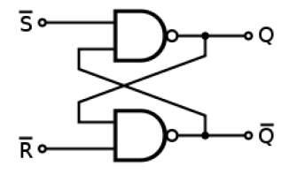

The operation of the S’R’ latch is as defined in these tables. Q(t) is the output of the latch at the current time, and Q(t+1) is the next output of the latch that will follow given the current Q(t), S’, and R’ logic levels.

Characteristic Table.

|  |  |  |  |
| --- | --- | --- | --- |
| **S’** | **R’** | **Q(t)** | **Q(t+1)** |
| 1 | 1 | X | Q(t) |
| 0 | 1 | X | 1 (set) |
| 1 | 0 | X | 0 (reset) |
| 0 | 0 | X | Not allowed |

Excitation table. This table re-states the information of the Characteristic Table in a form convenient for designing logic circuits that will command the S’R’ latch. This table shows each possible current, Q(t), and next, Q(t+1), output logic level combination, and what inputs values for S’ and R’ will cause the desired transition.

|  |  |  |  |
| --- | --- | --- | --- |
| **Q(t)** | **Q(t+1)** | **S’** | **R’** |
| 0 | 0 | 1 | X |
| 0 | 1 | 0 | 1 |
| 1 | 0 | 1 | 0 |
| 1 | 1 | X | 1 |

Become familiar with the RGB LED in your lab kit. The RGB LED combines three standard LEDs of colors red, green, and blue, into a single package with a clear plastic lens and four wire leads. It looks like this.

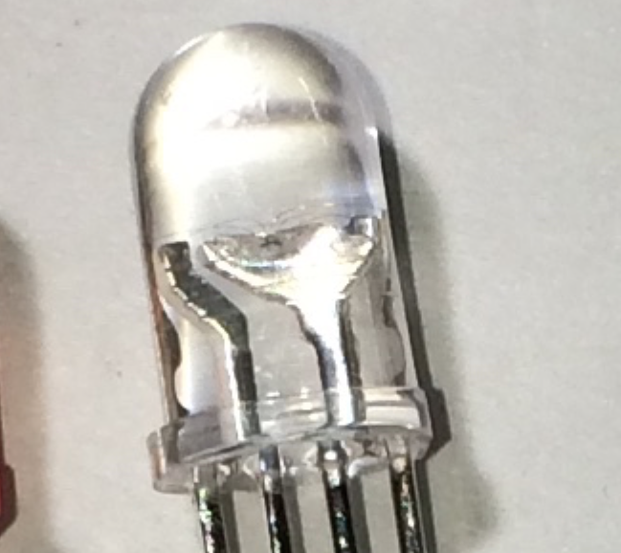

The pin diagram for the RGB LED is this.

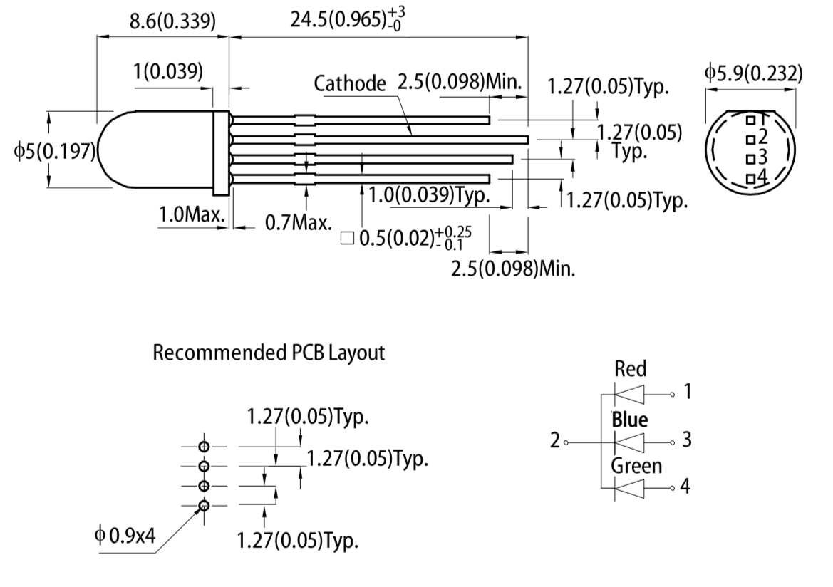

## Step 2 ­– Design the S’R’ latch and RGB LED circuit

Design a circuit using components from your lab kit that meets the following specifucations.

1. Four active low pushbutton inputs to generate the four logic signals Master_Reset’, Red_Set’, Green_Set’, and Blue_Set’.
2. Three S’R’ latches built using 2-input NAND gates.
3. The R’ inputs for all three latches are the logic signal Master_Reset’.
4. The logic signals Red_Set’, Green_Set’, and Blue_Set’ each connect to one S’ input of one latch.
5. The Q output of the latch with input Red_Set’ is connected to a 470 ohm resistor and thence in series to the Red lead of the RGB LED. Similarly, connect the Q outputs of the latches with inputs Green_Set’ and Blue_set’ to the respective green and blue leads of the RGB LED.
6. Connect the Ground lead of the RGB LED to ground.

## Step 3 – Build the circuit on your breadboard

Before you start to build your circuit, review the Circuit Grading Rubric below. Build your circuit design from Step 2 on your breadboard. Make use as needed of the Appendix: Helpful Reference Information section at the end of this lab document.

On a sheet of notebook paper, write labels that will clearly indicate which pushbutton controls the value of the input signals Master_Reset’, Red_Set’, Green_Set’, and Blue_Set’. Position the labels on this sheet such that when you set your breadboard on the sheet it will be clear to everyone, by looking down on the breadboard and the sheet, which breadboard component is meant by each label.

Correct operation of the circuit requires that only one pushbutton may be pushed at a time.

A correct circuit behaves as follows.

1. Pressing the button for Master_Reset’ turns off all RGB LED colors that were on, and all colors remain off after the press ends.
2. Pressing the button for Red_Set’, Green_Set’, or Blue_Set’ causes the red, green, or blue emitter, respectively, in the RGB LED to light up and remain lit after the pushbutton press ends.
3. When no pushbutton is pressed the illumination state of the RGB LED does not change.

Note that mixing two or more illumination colors is possible.

## Step 4 – Upload answers to the following questions before your lab session next week; In lab next week, demonstrate your circuit and be prepared to answer quiz questions about this lab from your TA.

## Grading:

Your lab grade will be based on your circuit demonstration, written answers to the questions below, and your answers to quiz questions during your circuit demo from your TA.

**Circuit Grading Rubric.** Your circuit demonstration can earn up to 55 points, comprised as follows:

[5 points] Breadboard circuit includes 10 Ohm resistor correctly protecting against short-circuit faults.

[10 points] Pushbutton input placement is consistent with the label sheet and the pushbuttons are physically easy to access and operate by your TA.

[5 points] Pushbutton inputs are of the specified logic level type.

[15 points] The circuit behaves per the “correct operation” statement in Step 3 of the instructions.

[20 points; 5 points each] Four live-answer quiz questions about your circuit will be asked of you by your TA at the time that you demonstrate your circuit.

**\*\*\*\* Disassemble your decoder circuit in the presence of your TA. Do not remove the 10 Ohm resistor and power and ground bus jumper wires. \*\*\*\*\***

Your written answers to the following questions can earn up to 45 points.

Question 1. [10 points]. Draw the circuit schematic for your design at the level of abstraction shown in the following schematic.

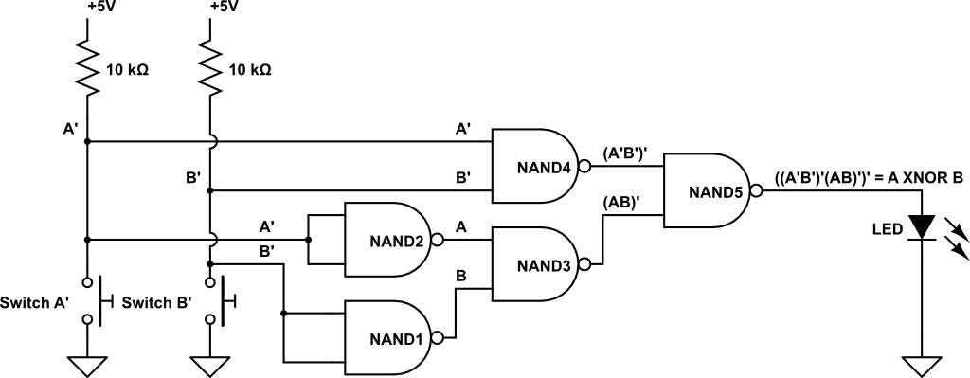

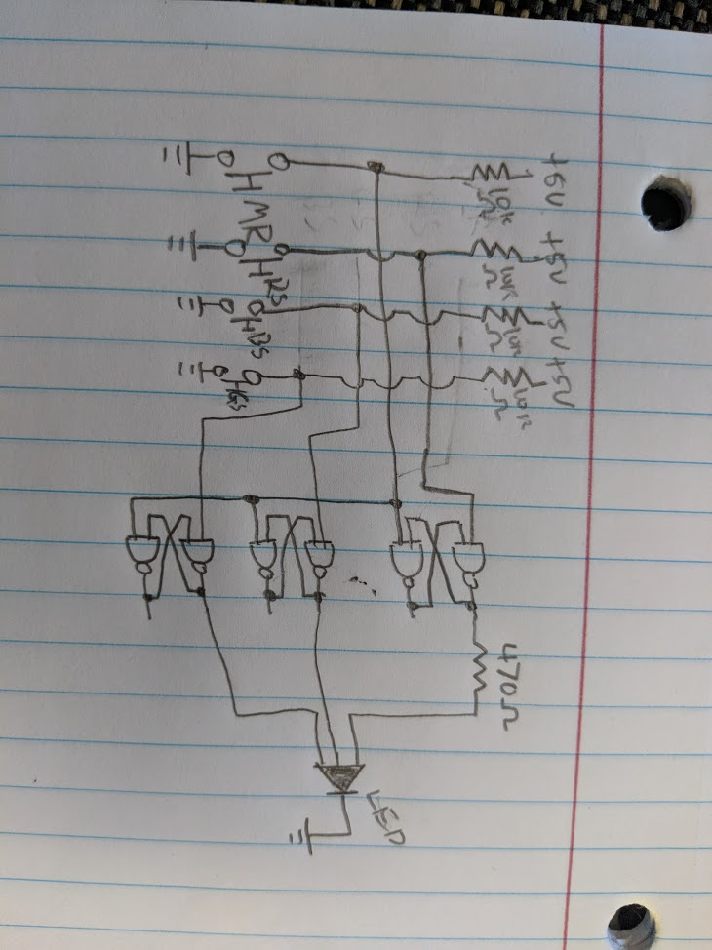

Question 2. [10 points] Re-draw a schematic for your circuit design that abstracts the inputs to text labels and latches to box (rectangle) icons with appropriately labeled inputs and outputs for only the used inputs and outputs (unused inputs or outputs are also abstracted out of the diagram to simplify the result). 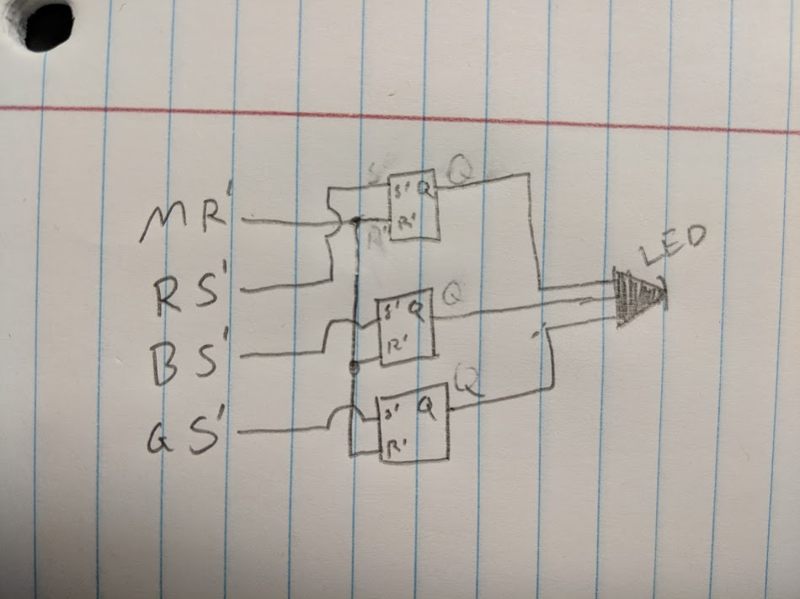

Question 3. [5 points] Fill in the empty characteristic table below to show how the table contents if 2-input NOR gates were used to build the latch instead of NAND gates.

|  |  |  |  |
| --- | --- | --- | --- |
| S | R | Q(t) | Q(t+1) |
| 0 | 0 | No change | No change |
| 0 | 1 | 1 | 0 |
| 1 | 0 | 0 | 1 |
| 1 | 1 | invalid | invalid |

Question 4. [5 points] Explain each difference in the characteristic table for the NAND latch and the NOR latch, starting with the assertion levels of the Set and Reset inputs. **The normal state for the NOR is 00 and the normal state for NAND is 11. The NOR is invalid at 11, and the NAND is invalid at 00.**

Question 5. [10 points] What happens to the RGB LED illumination state when pressing an <Any-Color>_ Set’ input of your circuit more than once? Explain what happens for all cases for any one color and give reasons. **If you press the same set input over and over again nothing happens, but if you press another color input after then both inputs will show on the LED and give it a different color.**

Question 6. [5 points]. In what way does designing with Master_Reset constrain the operation of the LED? **It makes it so that the LED must be reset before switching between colors.**

## Appendix: Helpful Reference Information

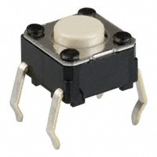

A pushbutton switch schematic that looks a bit like the actual switch is this. Rotate the schematic 30 degrees counterclockwise if you would like to align it with the image above.

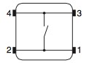

The DIP packages containing NAND gates (also known as (a.k.a.) chips) are the ones labeled SN74HCT00N, which we can call 7400 for simplicity. Here are pin diagrams for three chips in the 7400 series included in your lab kit, the 7400 Quad 2-input NAND, the 7402 Quad 2-input NOR, and the 7404 Quad Inverter. These diagrams show you which pins on the chips correspond to which portion of a particular gate (each chip has multiple gates on it). The “notch” on one end of the package identifies the number 1 pin.

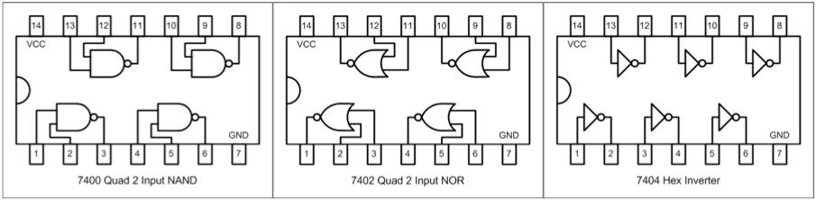

Make sure you can read the tiny label print on the top of the chip when referencing the diagram: if the part number on the chip is upside down, then you are holding the chip upside down.

At any point if you want to test your construction, you can use an LED as a visual probe. Think of it as a hardware version of a PRINT statement in a programming language. Just connect the LED anode (longer lead) to the circuit node you wish to interrogate (variable to print out) and connect the other LED lead to breadboard ground. The LED will light when the circuit node is at logic 1 (high voltage) and not light if the circuit node is at low voltage or is not connected to anything (called an open circuit).

**Parts Layout on the Breadboard.** A good starting strategy is to place the main components of your circuit on the breadboard first, particularly switches and DIP devices. Place switches where you can easily reach them. If there will be several, space the switches to give room for your fingers to reach each switch simultaneously. This will allow you easily press the switches in any combination that may be needed. DIP packages are large, which is a good reason to place them on the breadboard next.